**St. Louis Friends of Bethlehem**

Proudly presents the acclaimed artist

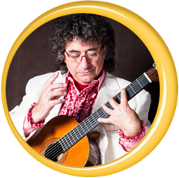

***A New Kind of Guitar Feeling***

--« Classical Guitar Music from Spain »--

Classical & Popular from Latin America

Plus a Contemporary Suite:

Jazz, Swing, Be-bop, Blues

*The Ethical Society of Saint Louis*

9001 Clayton Road 63117

**Saturday, October 25, 2025**

**7:30 pm**

For ticket information, please call Terry, 314.276.9452

or email [terryfwerner@gmail.com](mailto:terryfwerner@gmail.com) or use the QR code

Adults: $30.00 – Seniors: $20.00 – Students: $15.00

*A fundraiser for the children of Palestine*

Visit our website https://st-louis-friends-of-bethlehem.square.site/

We are a 501(c)(3). Donations are always welcomed.